SENNHEISER GROUP INTRODUCES NEW EXECUTIVE MANAGEMENT BOARD
The family-owned company starts 2023 with a new management team

Wedemark. January 23, 2023 – Following the realignment of the company with a focus on the professional audio business, the Sennheiser Group is entering 2023 with a newly formed management team. The audio specialist’s new Executive Management Board includes representatives from the three business units Pro Audio, Business Communication and Neumann, as well as Supply Chain, Corporate Functions and Development. Together with Co-CEOs Daniel and Andreas Sennheiser, the Board members will implement the strategic goals of the Sennheiser Group.

As of January 1, 2023, the operational business of the Sennheiser Group will be managed by a team of six: The new Executive Management Board (EMB) includes Greg Beebe (Executive Vice President Professional Audio), Ron Holtdijk (Executive Vice President Business Communication), Ralf Oehl (CEO Georg Neumann GmbH), Steffen Heise (CFO), Dr. Andreas Fischer (COO) and Markus Redelstab (CTO). Peter Claussen and Thomas Weinzierl, who were previously COOs responsible for Professional Business and Supply Chain, will also remain on the EMB before their respective retirements in the course of the years 2023 and 2024. In the intervening period, they will gradually hand over their operational tasks and extensive knowledge to the new EMB. In the future, Co-CEOs Dr. Andreas and Daniel Sennheiser will primarily focus on corporate management and strategy development and devote more time to customers, while the other EMB members will manage the operational business. Yasmine Riechers and Mareike Oer complete the leadership of the Sennheiser Group as an extended management team, representing the Corporate Development Office and Brand & Corporate Communication.

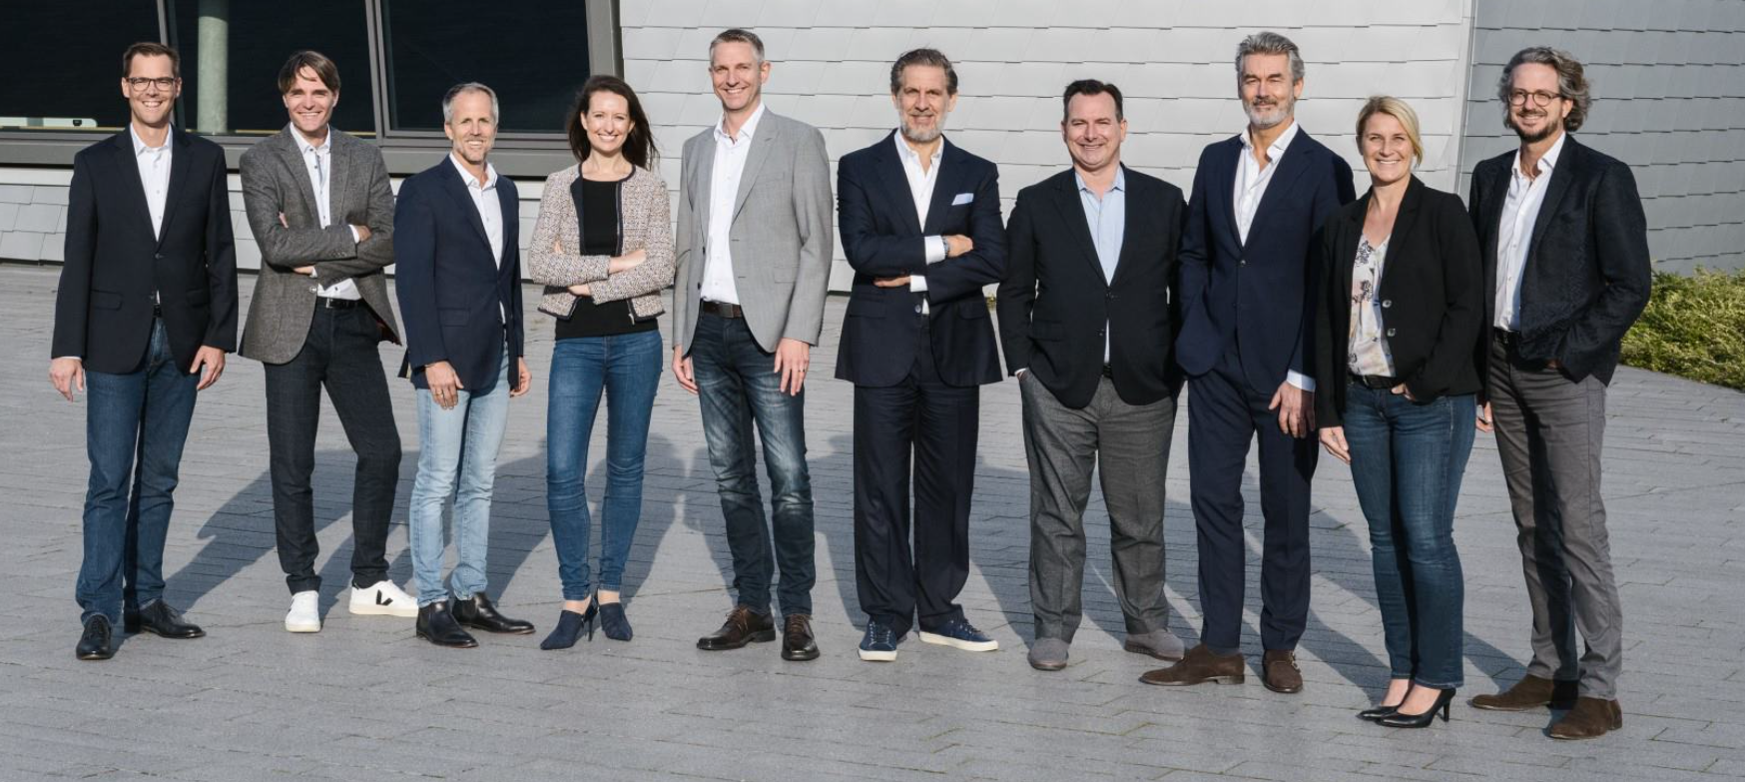
The new management team of the Sennheiser Group, consisting of Co-CEOs, EMB and extended EMB (from left to right): Steffen Heise, Markus Redelstab, Dr. Andreas Sennheiser, Yasmine Riechers, Dr. Andreas Fischer, Ralf Oehl, Greg Beebe, Ron Holtdijk, Mareike Oer,
Daniel Sennheiser

"With the integration of the business units into the EMB, our customers are moving even more into focus," explains Co-CEO Andreas Sennheiser. "In the future, their very different needs will be represented at the highest management level and included in all decisions, enabling us to act even closer to the market." The inclusion of product development into the direct scope of the EMB also reflects the great importance of this area and the associated efforts to align innovations and new technologies even more closely with customer needs. And by dovetailing all central functions with the business units, the different perspectives will be brought together in a new, strong management team.
With the changes in the Executive Board, Sennheiser’s North America organization has been able to promote several colleagues across the business unit. Mark Posgay has been appointed Senior Vice President, Global Sales, Professional Audio, overseeing the Americas, EMEA and APAC regions. Leading the local sales team is Edward Capp who is now Vice President, Sales, Professional Audio Americas. Other changes in the Professional Audio organization include Victor Baut’s expanded role as, Sales Director, Professional Audio East USA and Canada, Barry Mitchell, newly hired Sales Director, Professional Audio West USA, Matt Buckner, who is now Manager, Business Development Americas, and Greg Simon, newly promoted to Regional Manager Americas, Technical Applications Engineering.

Team spirit and collaborative leadership
"With this step, we are adapting our management structure to our new corporate positioning with a focus on the Professional Business," explains Co-CEO Daniel Sennheiser. "At the same time, we are further developing our leadership culture – in line with our corporate culture." The Co-CEOs have already been leading the family-owned company as part of a dual management team since 2013. The new set-up, whose introduction was accompanied by Peter Claussen, is also shaped by this management philosophy: "We are firmly convinced that rigid hierarchies in corporate management are outdated. Just as we as Co-CEOs share overall responsibility for our family-owned company, we will also shape the path for Sennheiser in the expanded management team," said Andreas Sennheiser. "After all, the most important guarantor of our future success is the people who work together worldwide under the umbrella of the Sennheiser Group. Our shared culture and our passion for what we do unite us. With the new EMB setup, we are also reflecting this ethos in our corporate management."

A successful business year and further investments
As part of its focus on professional audio business, Sennheiser had announced investments in this area in line with its new corporate strategy, which are now being implemented on a step by step basis. For example, a new PCB assembly line went into operation at the main site in Wedemark near Hanover at the end of 2022. Further investments in development and in the production site in Romania are planned.

Even though the final results will not be available until later in the year, an initial very positive assessment can already be made for 2022: Sennheiser was again able to record significant growth last year. This was even higher than the previous year's growth - despite the difficult global economic climate with inflation, supply chain bottlenecks, rising costs and geopolitical events affecting markets around the world. Co-CEO Daniel Sennheiser sums up: "We are on the right track with our strategy. And we have clear goals for the future of the Sennheiser Group. We know our strengths and we are consistently expanding them. The newly formed EMB will pursue these goals together. We therefore look to 2023 with a great deal of confidence, and we enter this year with a strong, motivated management team of which we are very proud."

About the Sennheiser Group
Building the future of audio and creating unique sound experiences for our customers - this is the aspiration that unites the employees of the Sennheiser Group worldwide. The independent family-owned company Sennheiser was founded in 1945. Today, it is managed in the third generation by Dr. Andreas Sennheiser and Daniel Sennheiser and is one of the leading manufacturers in the field of professional audio technology. Within the Sennheiser Group are Georg Neumann GmbH (Berlin, Germany), manufacturer of studio-grade audio equipment; Dear Reality GmbH (Düsseldorf, Germany), known for its binaural, Ambisonics, and multichannel encoders with realistic room virtualization; and Merging Technologies SA (Puidoux, Switzerland), specialist in high-resolution digital audio recording systems.
sennheiser.com | neumann.com | dear-reality.com | merging.com
Press Contact
Sennheiser Group
Mareike Oer
Brand & Corporate Communication
T +49 (0)5130 600-1719
mareike.oer@sennheiser.com

